DIS-AM,C-Taino-Cemi-Mother Goddess-Birthing

John Therien Estate, NYC, 6/25/68 Collected

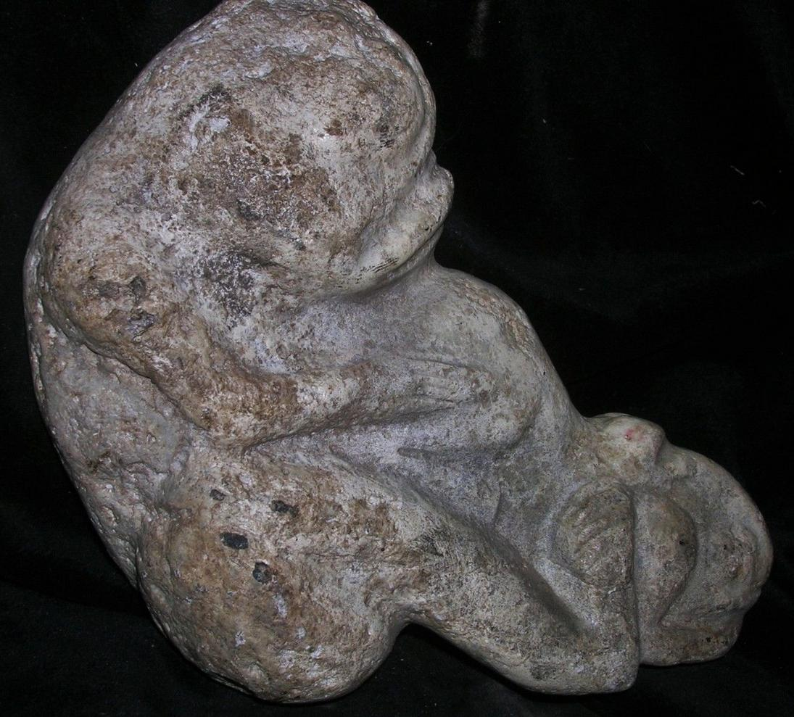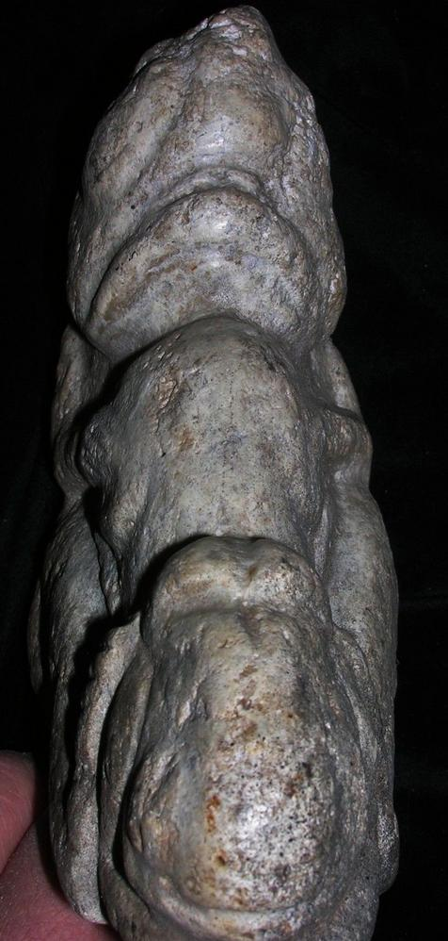

Sold by [primitifstuffgal...](http://myworld.ebay.com/primitifstuffgallery) ( [2214](http://feedback.ebay.com/ws/eBayISAPI.dll?ViewFeedback&userid=primitifstuffgallery) )

### Delivery package 1 of 1

Estimated delivery Tuesday, Mar 29, 2016 - Friday, Apr 1, 2016

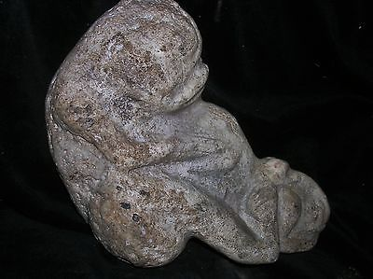

#### [ORIG $399. PRE COLUMBIAN TAINO FIGURE 7➕" PROVENANCE](http://www.ebay.com/itm/222058876885)

|  |  |
| --- | --- |
| Item price | $99.99 |
| Quantity | 1 |
| Item number | 222058876885 |
| Shipping service | USPS Priority Mail |

## Shipping address Ralph J Coffman Jr149 Atlantic AveSwampscott MA 01907-2427United StatesOrder total

|  |  |
| --- | --- |
| Subtotal | $99.99 |
| Shipping | $10.92 |

**Total**$110.91

Order placed onTuesday, Mar 22, 2016 Payment methodPayPal Payment dateTuesday, Mar 22, 2016